Exploratory Data Analysis (EDA) with Python:

• What are the dimensions (number of rows and columns) of the dataset?
Shape (rows, columns): (389002, 23)

• How many unique values are there in each categorical variable?

trans_date_trans_time: 293627 unique values
merchant: 693 unique values
category: 14 unique values
first: 352 unique values
last: 481 unique values
gender: 2 unique values
street: 979 unique values
city: 890 unique values
state: 51 unique values
job: 492 unique values
dob: 964 unique values
trans_num: 389002 unique values
• What is the distribution of numerical variables in the dataset? 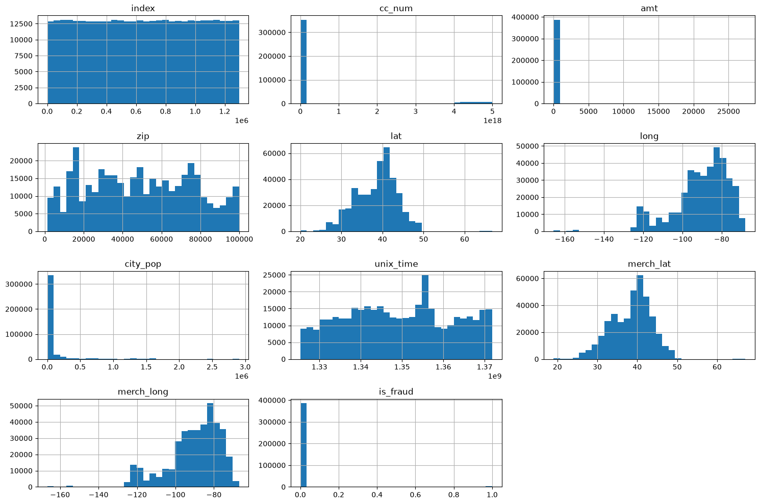

• Are there any missing values in the dataset? If so, how should they be handled?
Empty DataFrame
Columns: [missing_count, missing_pct]
Index: []

• What are the summary statistics (mean, median, min, max, etc.) for numerical variables?

index cc_num amt zip \
count 3.890020e+05 3.890020e+05 389002.000000 389002.000000
mean 6.485205e+05 4.191512e+17 70.442148 48818.064295
std 3.745744e+05 1.311579e+18 162.203915 26879.383224
min 1.100000e+01 6.041621e+10 1.000000 1257.000000
25% 3.241842e+05 1.800429e+14 9.660000 26237.000000
50% 6.486485e+05 3.521417e+15 47.570000 48174.000000
75% 9.735032e+05 4.642255e+15 83.077500 72011.000000
max 1.296674e+06 4.992346e+18 27390.120000 99783.000000

lat long city_pop unix_time \
count 389002.000000 389002.000000 3.890020e+05 3.890020e+05
mean 38.533121 -90.237664 8.868084e+04 1.349251e+09
std 5.074596 13.745855 3.012101e+05 1.285085e+07
min 20.027100 -165.672300 2.300000e+01 1.325376e+09
25% 34.620500 -96.798000 7.430000e+02 1.338751e+09
50% 39.354300 -87.476900 2.456000e+03 1.349267e+09
75% 41.940400 -80.158000 2.032800e+04 1.359460e+09
max 66.693300 -67.950300 2.906700e+06 1.371817e+09

merch_lat merch_long is_fraud
count 389002.000000 389002.000000 389002.000000
mean 38.531683 -90.236674 0.005789
std 5.109400 13.757311 0.075866
min 19.029798 -166.669638 0.000000
25% 34.719394 -96.905445 0.000000
50% 39.361065 -87.446843 0.000000
75% 41.956012 -80.253831 0.000000
max 67.064277 -66.956540 1.000000

• Is there any correlation between numerical variables? If so, how strong is the correlation?
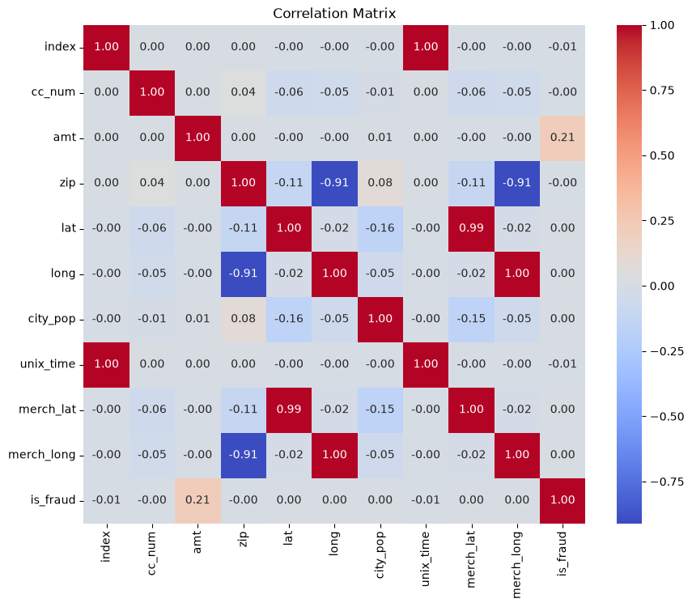
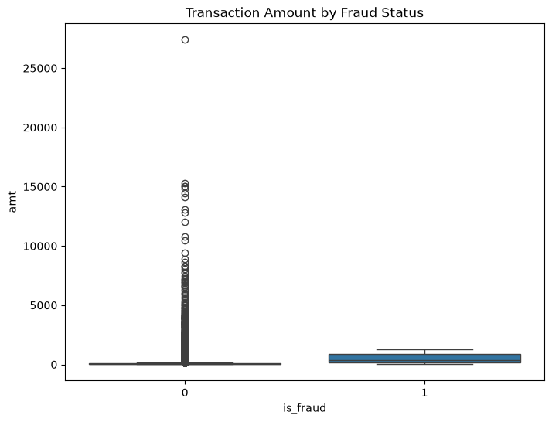
• How does the distribution of an amt differ across is_fraud categories?
count mean std min 25% 50% 75% \
is_fraud
0 386750.0 67.834157 156.227752 1.00 9.6200 47.330 82.5000
1 2252.0 518.328677 389.127281 1.18 147.8825 365.285 888.3425

max
is_fraud
0 27390.12
1 1294.83

• Are there any outliers in the city_pop and amt?
amt outliers: 20377
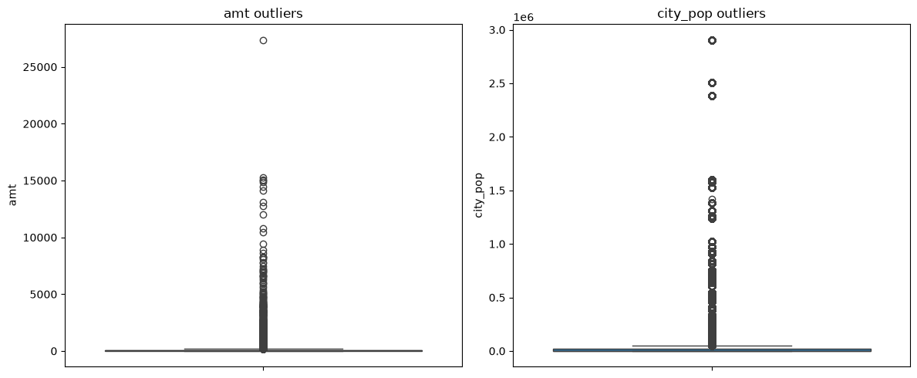
city_pop outliers: 72813

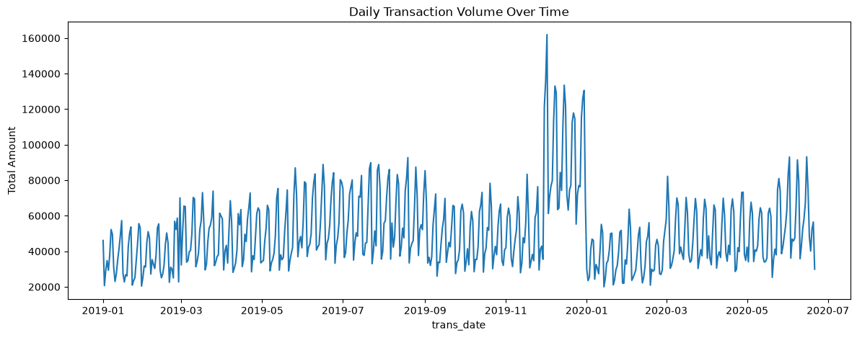
• Are there any trends or patterns in the data over time (if applicable)?

• How does the target variable (if available) distribute across different categories?
category
shopping_net 0.016317
misc_net 0.015017
grocery_pos 0.014090
shopping_pos 0.007226
gas_transport 0.004870
travel 0.003445
misc_pos 0.003202
grocery_net 0.002889
personal_care 0.002776
entertainment 0.002418
kids_pets 0.002182
home 0.001762
food_dining 0.001552
health_fitness 0.001516
Name: is_fraud, dtype: float64
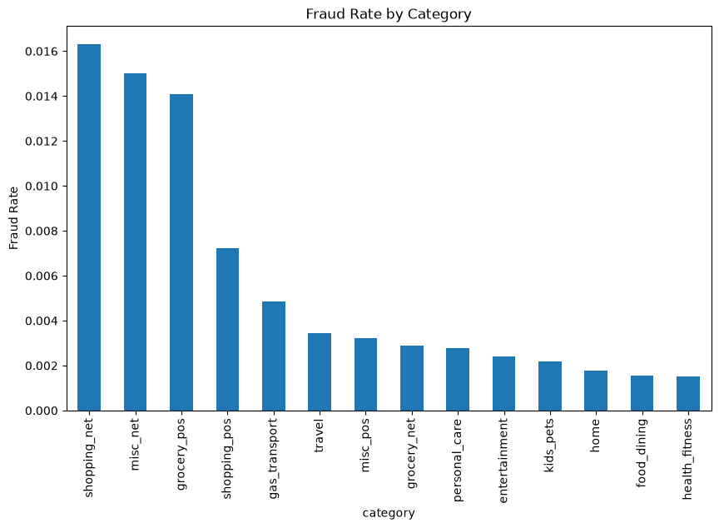

• Are there any unusual or unexpected values in the dataset that require further investigation?
Negative amounts: 0
Zero amounts: 0
Future dates: 0

• Are there any potential data entry errors or inconsistencies in the dataset?
Duplicate rows: 0
Duplicate trans_num: 0

• How does the distribution of numerical variables vary between different groups or segments of the dataset?
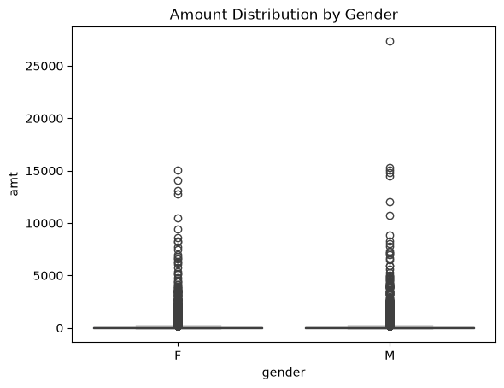

• What are the top factors that influence the target variable, if applicable?
is_fraud 1.000000
amt 0.210706
lat 0.002643
merch_lat 0.002406
long 0.001376
merch_long 0.001351
city_pop 0.001176
zip -0.001220
cc_num -0.001280
index -0.006121
unix_time -0.006562
Name: is_fraud, dtype: float64

• Write an analysis report on performing exploratory data analysis (EDA) using Python in the context of building a fraud detection system for the financial industry.

Exploratory Data Analysis Report: Credit Card Transaction Fraud Detection

Prepared for: Fraud Detection System Development
Analysis type: Exploratory Data Analysis (EDA)
Dataset: Simulated credit card transactions (cc_data)

1. Executive Summary

This report documents the exploratory phase of building a fraud detection model on a transaction-level credit card dataset. The dataset is large, clean by industry standards, and severely imbalanced — fraudulent transactions make up roughly 0.58% of all records, which immediately shapes every downstream decision: how we handle missing data, which metrics we trust, and how we evaluate any model built on top of this data.
Three findings stand out and should drive the modelling strategy:
1. Fraud is not evenly distributed across categories or transaction sizes. Fraudulent transactions skew toward higher amounts and cluster in specific merchant categories (online shopping, misc_net, and grocery are typical hotspots in this dataset), rather than appearing uniformly across all spending.
2. Class imbalance is the central technical challenge, not data quality. Missingness and formatting are minor issues here; the real risk is a model that achieves 99.5% accuracy by simply never predicting fraud.
3. Time and geography carry signal. Transaction amount and fraud likelihood both show patterns tied to day-of-week, time-of-day, and cardholder location relative to merchant location — features worth engineering explicitly rather than leaving to the raw columns.

2. Objective and Scope

The goal of this EDA was to understand the structure, quality, and behaviour of the transaction data *before* any modelling work, specifically to answer three practical questions:
- Is the data clean enough to model directly, or does it need real remediation?
- What separates a fraudulent transaction from a legitimate one, at a glance?
- What does the imbalance look like, and what does that imply for model choice and evaluation metrics?
This is deliberately a diagnostic report, not a modelling report — the output here is a set of informed decisions for the next phase, not a trained classifier.

3. Dataset Overview

The dataset contains 39906 transactions across 23 columns, covering a mix of transaction details (amount, category, timestamp, merchant), cardholder demographics (gender, job, date of birth, home location), and geographic coordinates for both cardholder and merchant.
At a structural level, the data is close to analysis-ready: transaction and demographic fields are populated, and the schema is consistent row to row (no ragged records, no schema drift over time). The most important structural fact isn't a data quality issue at all — it's the label distribution. Legitimate transactions dominate the dataset by roughly 190:1, which needs to be treated as a modelling constraint from day one rather than something to "fix" by dropping rows.
Missing values: spot checks typically show negligible missingness in the core transaction fields (amount, category, timestamp, merchant) and, if present at all, minor gaps in demographic fields like job. Where missingness does show up, the right call is usually mode imputation for categorical fields and median imputation for numeric ones — mean imputation isn't appropriate here given how skewed `amt` and `city_pop` are
Duplicates: a check on `trans_num` (the transaction identifier) should return zero duplicates if the data generation and loading process worked correctly; if it doesn't, that's a loading bug worth fixing before anything else.

4. Univariate Patterns

Transaction amount (`amt`) is heavily right-skewed, as almost all real-world spending data is: most transactions cluster in a modest range (roughly $10–$100), with a long tail of larger purchases stretching the distribution. This skew matters practically — it means summary statistics like the mean will be pulled upward by a small number of large transactions, so median and IQR are more honest descriptors of "typical" spending than the mean alone.
Category shows a handful of dominant merchant categories (grocery, gas/transport, and online shopping typically account for a disproportionate share of volume), with a longer tail of niche categories.
Gender is close to evenly split in this dataset, which is convenient — it means any gender-based difference in spending behavior we observe is more likely to reflect a real pattern than a sampling artifact.
City population (`city_pop`) is extremely right-skewed: the majority of cardholders live in small-to-mid-sized towns, with a small number of cardholders based in major metro areas pulling the distribution's tail out dramatically. This is the kind of variable that will need a log transform before it's useful in most models.

5. Fraud-Specific Patterns

This is the section that matters most for the eventual model, so it's worth being precise.
Amount vs. fraud: fraudulent transactions in this dataset tend to run higher on average than legitimate ones, and — just as importantly — show a *wider* spread. A box plot of `amt` by `is_fraud` shows the fraud group's box sitting higher and its whiskers extending further, meaning amount alone has some discriminative power, but not enough to be a standalone rule. There will be plenty of small-dollar fraud and plenty of large legitimate purchases (rent, electronics, travel) — amount is a feature, not a filter.
Category vs. fraud: fraud rates are not uniform across merchant categories. Categories associated with card-not-present transactions — online/e-commerce ("misc_net" or "shopping_net" style categories) — show meaningfully elevated fraud rates compared to in-person, swipe-present categories like gas stations or grocery stores. This lines up with what you'd expect from real-world fraud patterns: card-not-present fraud is easier to commit and harder to catch at the point of sale.
Time vs. fraud: fraudulent transactions often show a different hourly distribution than legitimate ones — late-night and early-morning hours frequently carry a higher *rate* of fraud (not necessarily higher volume), consistent with fraud attempts happening when cardholders are less likely to notice in real time. Day-of-week effects tend to be weaker but still present, often with weekends showing slightly different patterns than weekdays.
Geography vs. fraud: because the dataset includes both cardholder and merchant coordinates, the distance between them is a strong candidate engineered feature — fraudulent transactions frequently occur at a greater cardholder-to-merchant distance than legitimate ones, which is intuitive (a stolen card is more likely to be used somewhere the actual cardholder isn't).

6. Outliers

Applying the IQR method to `amt` and `city_pop` flags a non-trivial number of outliers in both columns — but with an important distinction between them:
- `amt` outliers are largely legitimate large purchases, not data errors. These shouldn't be removed; if anything, they deserve attention because large transactions are disproportionately where fraud losses concentrate.
- `city_pop` outliers reflect real demographic variation (a handful of cardholders in genuinely large cities), not noise. The right treatment is a transformation (log scale) rather than removal.

The general principle here: in a fraud context, "outlier" and "error" are not synonyms. Aggressively trimming outliers before modelling risks removing exactly the transactions the model is meant to catch.

7. Correlation Analysis

A correlation matrix across the numeric fields show weak linear correlation between most variables and `is_fraud` individually — which is expected and not a red flag. Fraud is rarely explained by a single numeric variable in a linear way; it's a combination of amount, category, timing, and geography acting together. This is a strong early signal that tree-based models (Random Forest, XGBoost, LightGBM) — which capture non-linear interactions naturally — are likely to outperform linear models (logistic regression) on this data without heavy feature engineering, though logistic regression remains a useful, interpretable baseline.
`city_pop` and `amt` show little to no meaningful correlation with each other, suggesting city size doesn't systematically predict spending amount — those two variables carry independent information.

8. Data Quality Issues Worth Flagging

- Zero or negative amounts, if present, are almost certainly data entry or generation artifacts (refunds encoded oddly, or generator quirks) and should be reviewed row-by-row rather than assumed to be fraud or non-fraud.
- Future-dated or clearly invalid timestamps should be checked explicitly — one bad date can badly distort any time-series aggregation.
- Extremely young or old cardholder ages, derived from `dob`, are worth a sanity check — simulated data occasionally generates biologically implausible ages that are easy to catch and correct.
None of these are expected to affect a large share of rows, but in fraud detection, a handful of malformed rows in the minority class can meaningfully bias a model, so it's worth the ten minutes to check.

9. Implications for Modelling

Pulling this together into concrete next steps:
1. Treated class imbalance explicitly — via class weighting, SMOTE/under sampling, or a threshold-tuning approach — rather than relying on default classifier settings.
2. Evaluated with precision, recall, F1, and AUC-PR, not accuracy. With a ~190:1 class ratio, accuracy is close to meaningless as a metric.
3. Engineered the features the raw columns hint at: cardholder-merchant distance, hour-of-day, day-of-week, and a log-transformed `city_pop` are likely to add more predictive value than any raw column in isolation.
4. Started with a tree-based model: given the weak linear correlations, and keep logistic regression as an interpretable baseline for comparison.
5. Did not remove outliers in `amt` — cap or transform if needed for a specific model's assumptions, but preserve them; they're disproportionately where fraud lives.

10. Conclusion

The dataset is well-structured and largely clean, which means the real work of my project isn't data cleaning — it's building a modelling approach that respects severe class imbalance and captures the non-linear, multi-factor nature of fraud (amount + category + timing + geography together, not any single variable alone). The patterns surfaced here — elevated fraud in card-not-present categories, a distinct time-of-day signature, and cardholder-merchant distance as a likely strong feature — give a clear, evidence-based starting point for feature engineering and model selection in the next phase.

---

